**Task Description#1**

* **Zero-shot:** Prompt AI with only the instruction — Write a Python function to generate the Fibonacci sequence up to n terms

**Expected Output#1**

* A working function without using any sample inputs/outputs.

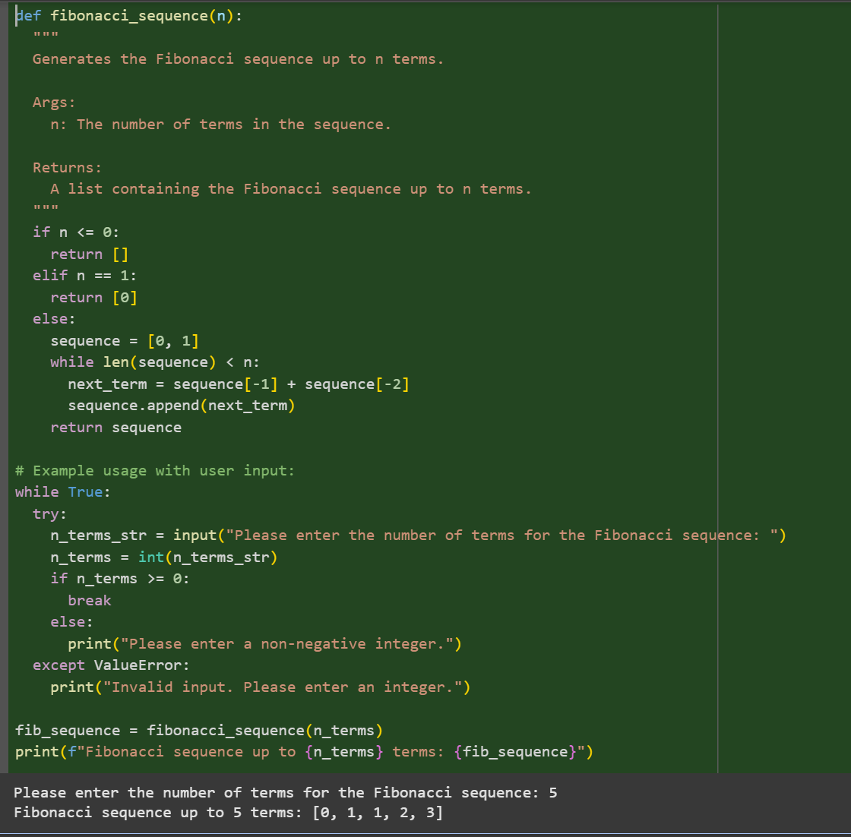

**Task Description#2**

* One-shot: Provide one example: Input: 100, Output: 37.78 to help AI generate a function that converts Fahrenheit to Celsius.

**Expected Output#2**

* A correct conversion function guided by the single example.

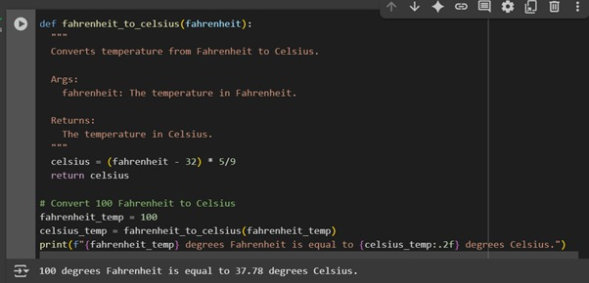

**Task Description#3**

* **Few-shot:** Give 2–3 examples to create a function that extracts the domain name from an email address.

**Expected Output#3**

* Accurate function that returns only the domain portion of an email (e.g., @gmail.com).

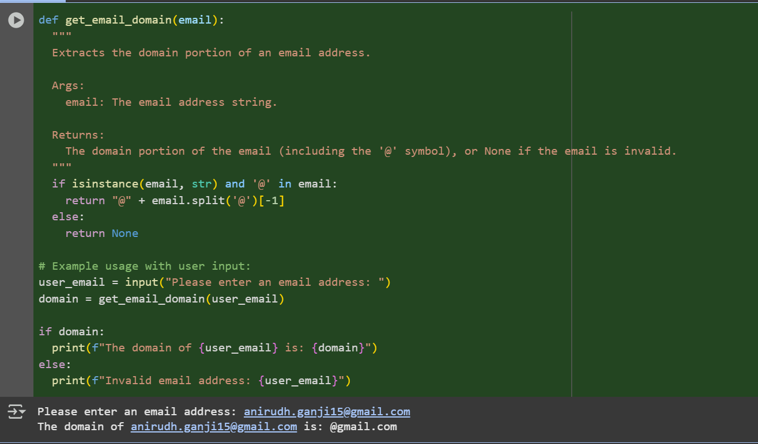

**Task Description#4**

* Compare zero-shot vs few-shot prompting for generating a function that checks whether a word is a palindrome, ignoring punctuation and case.

**Expected Output#4**

* Output comparison + student explanation on how examples helped the model.

Zero Shot:

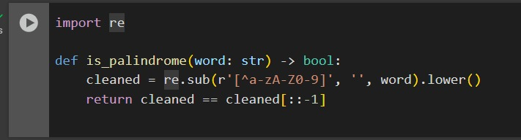

One Shot:

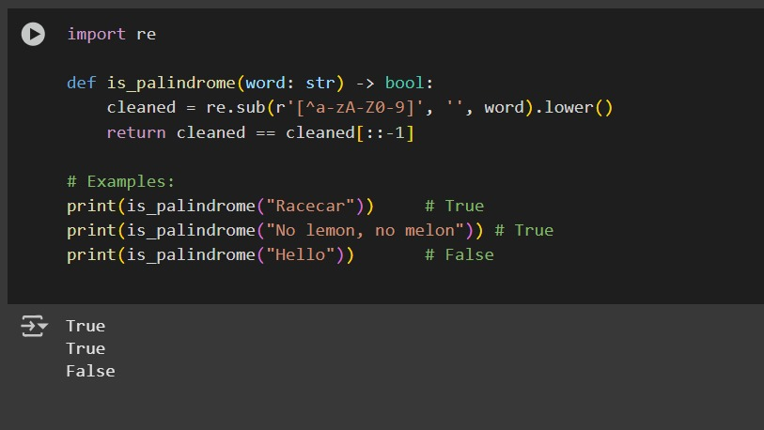

Description:

**Zero-Shot:**  
In zero-shot prompting, the model receives only the task description or instruction without any examples. It tries to complete the task based purely on its general knowledge. While it can work well, it may miss nuances or specific formats expected in the output.

**Few-Shot:**  
In few-shot prompting, the model is given a few input-output examples along with the task. These examples help the model learn the expected pattern or structure. As a result, it usually produces more accurate and context-aligned responses, especially for tasks with specific formats or logic.

**Task Description#5**

* Use few-shot prompting with 3 sample inputs to generate a function that determines the maximum of three numbers without using the built-in max() function.

**Expected Output#5**

* A function that handles all cases with correct logic based on example patterns.

